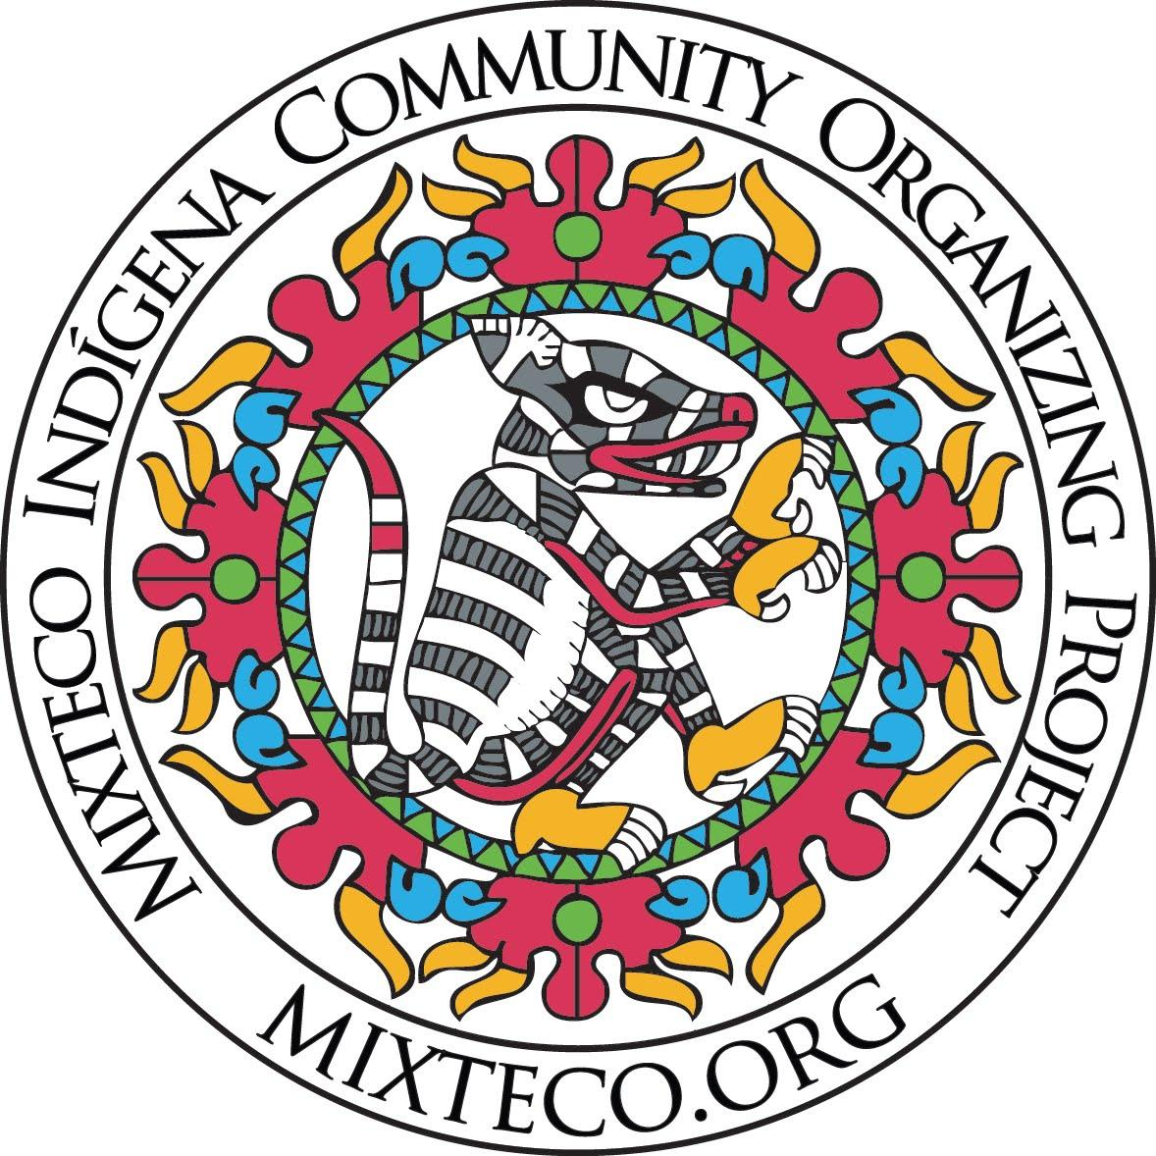
TEQUIO SCHOLARSHIP FUND

Mixteco/Indígena Community Organizing Project

P.O. Box 20543 Oxnard, CA 93034-0543
Tel: 805 483-1166 www.mixteco.org

MICOP’s TEQUIO SCHOLARSHIP FUND
APPLICATION PERIOD - APRIL 14th-MAY 14th 2021

“As you climb, may you lift your community with you.”

The Indigenous concept of “Tequio'' is ancestral cultural legacy among the Indigenous communities which can be described as "a disposition of wills that seek to meet needs or solve collective problems through community organization” (Mentado 2017). Established in 2012 the Tequio Scholarship Fund shares this commitment to serve our Indigenious community by inspiring and encouraging academic success providing scholarships to Indigenous Mexican students. Our scholarship recipients include high school (seniors), community college, and university students from Ventura and Santa Barbara counties. In the spirit of Tequio, we seek to support highly motivated students who share this commitment to serve our Indigenous community.

MICOP is offering two scholarship types:
- Tequio Scholarship - Indigenous Mexican students attending college or university
- MICOP Edison Scholarship - Indigenous STEM students attending a 4 year university
- Please see eligibility criteria for both scholarships below.
Student Eligibility for the Tequio Scholarship Fund:
(Previous scholarship recipients are encouraged to apply)
- Open to students of Mexican Indigenous background.
- Reside in Ventura County or Santa Barbara County.
- Open to (2021) high school seniors, community college or university students (not restricted to traditional students or age groups).
- Enrolled or planning to enroll, Fall 2021 semester in college or university (part or full time is acceptable).
- Undocumented, AB540, DACA, and US citizens are eligible.

Student Eligibility for MICOP’s Edison Scholarship Fund:
(MUST meet the following requirements)
- Meet requirements for the Tequio Scholarship plus the following.
- Be a STEM major in the following fields: computer and information systems, engineering, engineering technology, management information systems, mathematics, natural resources and conservation and physical sciences.
- Enrolled, or planning to enroll, full-time at a four year university and have a cumulative GPA of 3.0 or higher. (Applicants for this scholarship must be full time students)

Application Materials:
(MUST include)
- Application and personal statement (see application instructions)
- (1) letter of recommendation from a professor, teacher, or community member (excluding MICOP)
- High school, college, university, or continuing education transcripts (official or unofficial)
- Proof of community college, university, or adult education enrollment
- Photo/Headshot in PNG/JPEG format
- Brief (3-4 sentence) biography
- Sign the waiver provided in the application giving MICOP access to your application information

Personal Statement:
Please complete the following on a separate sheet and include it with your application.
We want to get to know you! Please include 1-2 pages about yourself using the questions below. Additionally, we are open to you expressing yourself creatively. Alongside your written statement you may include spoken word, poetry, video documentation and your artistic expression (this is not a requirement but an opportunity to further highlight yourself). Use your personal statement as a way to show your Indigenous pride and share what being Indigenous means to you.

Please answer the following within your Personal Statement:

- How will this scholarship specifically support your educational goals for higher education?
- If you are awarded a scholarship how do you plan to use the funds?
- Please describe your commitment to the Indigenous migrant community.
- How will achieving your educational goals positively impact the Indigenous migrant community?

Application Deadline:
- Applications will be accepted from April 14th through May14th via email or online only. Recipients will be notified in June and will receive their award before the start of the 2021 school year.

Intended Use of Funds:
- Recipients may use scholarships funds as needed to support their studies.
- Recipients may be asked to submit a brief report after the first semester of college (including how funds were used). Some recipients may be asked to share their experience at future MICOP events.

Submit Your Application for the Tequio Scholarship Fund:
- Please email your application to scholarship@mixteco.org or submit online at mixteco.org/scholarship (All emailed documents must be a single file in PDF or JPEG format). Incomplete applications will not be considered. Application is based on documentation only and does not include an interview process. If you are having difficulty with submitting your application online please contact Dalia Garcia dalia.garcia@mixteco.org or call (805) 837-4508 to make an appointment to submit your application in person.

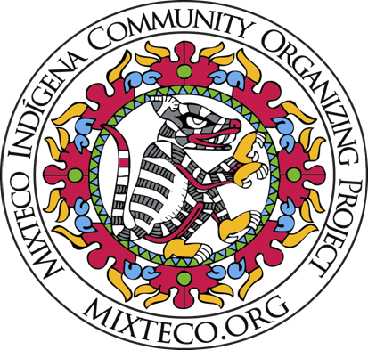
TEQUIO SCHOLARSHIP FUND
Mixteco/Indígena Community Organizing Project (MICOP)
P.O. Box 20543 Oxnard, CA 93034-0543
Tel: (805) 483-1166 www.mixteco.org

2021 TEQUIO SCHOLARSHIP APPLICATION
Application opens April 14th and will be accepted until May 14th online at mixteco.org.
Please fill out this application completely.

Name: ______________________________________________________________________________
Address: _________________________________City:________________ State:______ Zip:_________

Phone number: ( )________________ Email: ______________________________________

Date of Birth: _______(Month)________(Day)________(Year) ____
Current school*:____________________________________________________ Grade:______________ *Note: "If you are enrolled or will be enrolling in a college/university for the first time, please indicate where you received your high school diploma or GED."

List school you will be attending in Fall of 2021:_____________________________________
Indigenous Community(i.e., Mixteco, Zapoteco, Purepecha, Triqui, Otomi, Huave, Nahua): __________________________________________________________

Name of college/university of attendance for Fall 2021: ______________________________________
( ) Enrolled ( ) Plan to enroll
Please indicate which major or field of study you plan to pursue:_____________________________
Please indicate your current GPA: ________________

Are you applying for the Edison STEM Scholarship Funds?
Yes: _________ No: _________
Note: MICOP has received $15,000 in funds for STEM students. Eligible STEM majors include computer and information systems, engineering, engineering technology, management information systems, mathematics, natural resources and conservation and physical sciences. Eligible students must be planning to attend college full-time at a four year university and have a cumulative GPA of 3.0 or higher.

What year will you be in for the 2021-2022 academic year?
( ) Freshman/first year in college
( ) Sophomore/second year in college
( ) Junior/third year in college
( ) Senior in college hoping to go to graduate school
( ) Other (Please explain):______________________________________________________

TEQUIO SCHOLARSHIP FUND
Mixteco/Indígena Community Organizing Project (MICOP)
P.O. Box 20543 Oxnard, CA 93034-0543
Tel: (805) 483-1166 www.mixteco.org

Are you/have you been involved with MICOP’s Tequio Youth Group?
*Please note MICOP Tequio Students will have priority to scholarship funds, however all eligible students will be considered.

Yes____ How long?__________
No____

The MICOP Tequio Youth Group team would like to support you with the application process. Please reach out to Dalia Garcia via email: dalia.garcia@mixteco.org for more information. The team will be holding information workshops and providing additional information on assistance with the application process.

For questions about the application and to submit online please visit our website mixteco.org/tequioscholarship.

TEQUIO SCHOLARSHIP:
AUTHORIZATION TO USE INFORMATION, NAME, AND LIKENESS
I understand that MICOP requires the right to use my name and likeness, as well as information from my Scholarship Application, personal statement, and letters of recommendation as part of its publicity about MICOP’s Tequio Scholarship Fund, and fundraising for MICOP’s Tequio Scholarship Fund, and their other programs. I hereby authorize MICOP to use my name and likeness, as well as information from my Scholarship Application, personal statement, and letters of recommendation, at its discretion.
_______________________________________ ____________________________
Candidate Signature Date

IF UNDER 18 YEARS OLD:

Parent Signature Date

